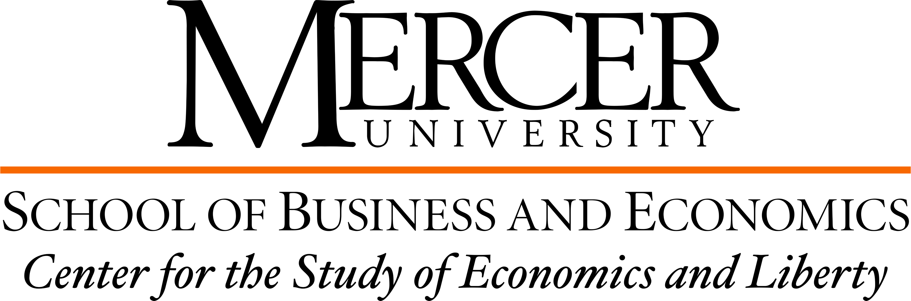

BOOK CLUB APPLICATION

DUE BY October 4, 2021

Name of student:

Student’s e-mail address:

Student’s class (freshman, sophomore, etc.):

Student’s major/department:

_________________________________________________________________________________________________________

Please answer the following questions (be brief).

- Have you taken ECN 150 or ECN 151 or both? What other ECN classes have you taken?

- Are you familiar with the book “The Invisible Heart” by Russell Roberts? Why are you interested in discussing it?

- What other books related to economics or politics have you read in the recent past? Are there any books/authors that you think will be relevant when reading/discussing The Invisible Heart?

Book clubs are very popular. We normally have more applications than available spots (we can only accept 10 applications per book club). If you are selected you will be taking a valuable spot. Thus, we need participants to take book clubs very seriously, do the readings and participate actively in the discussions. The $200 stipend would be conditional on successful completion of all five sessions.

All applicants will be contacted with a decision by October 11, 2021. Selected students will receive a free copy of the book. The book club starts on October 18, 2021. The rest of the sessions are on 10/20, 10/22, 10/25 and 10/27 at 5:30 pm in the Stetson building (the room number will be announced in due time).

Please this application to Dr. Antonio Saravia at saravia_av@mercer.edu.

